Q.1. Git Setup https://confluence.atlassian.com/bitbucket/set-up-git-744723531.html
Ans: $ sudo apt-get install git

Q.2.Initialize a Git Repository
Ans: git init

Q.3.Add files to the repository
Ans: git add files.txt

/home/ttn/Pictures/Screenshot from 2019-02-05 15-53-03.png

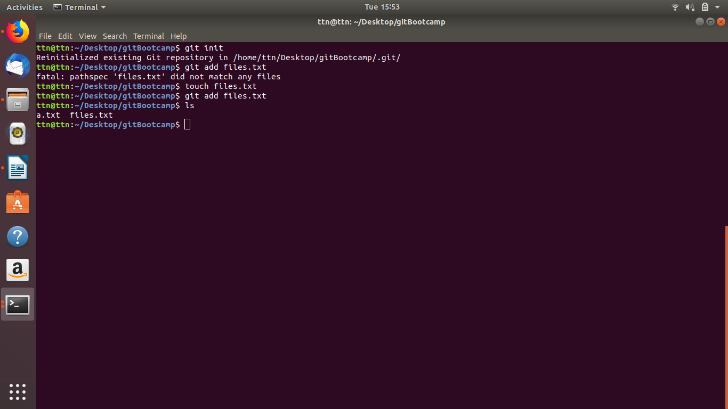

Q.4. Unstage 1 file.
Ans:
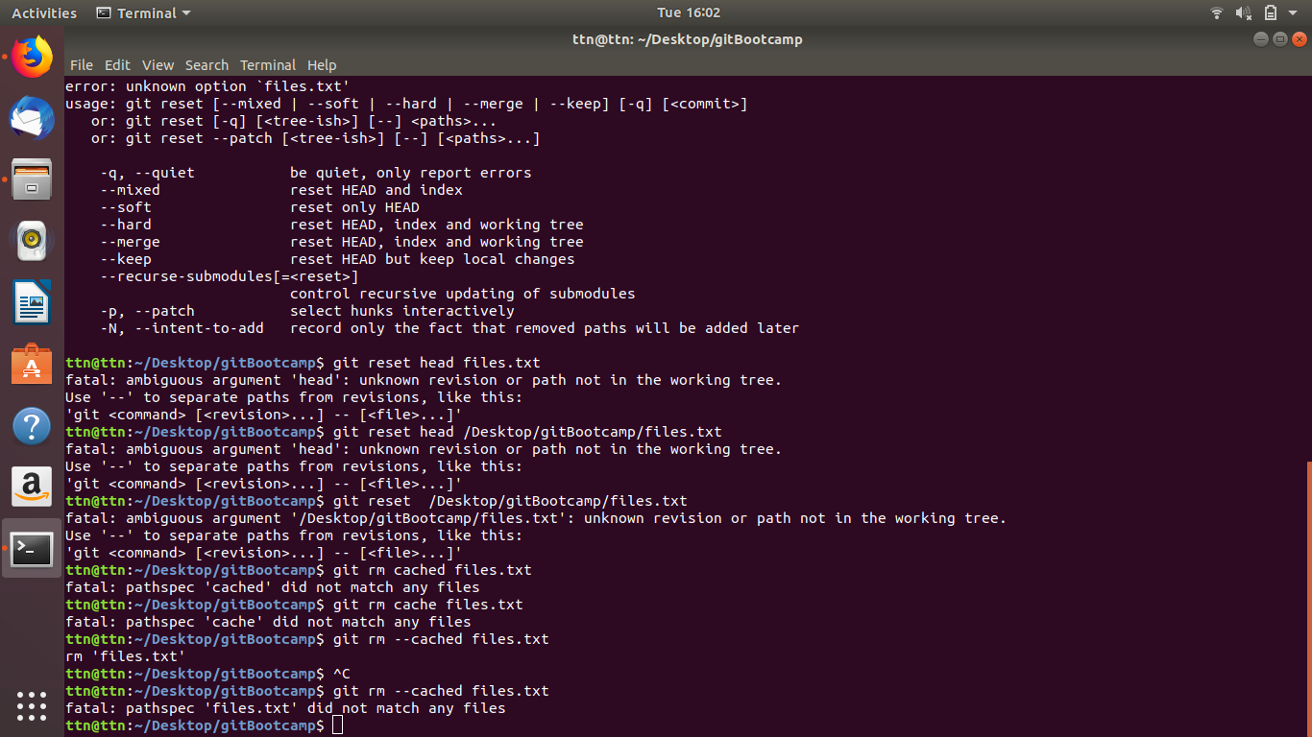

Q.5. Commit the file
Ans:
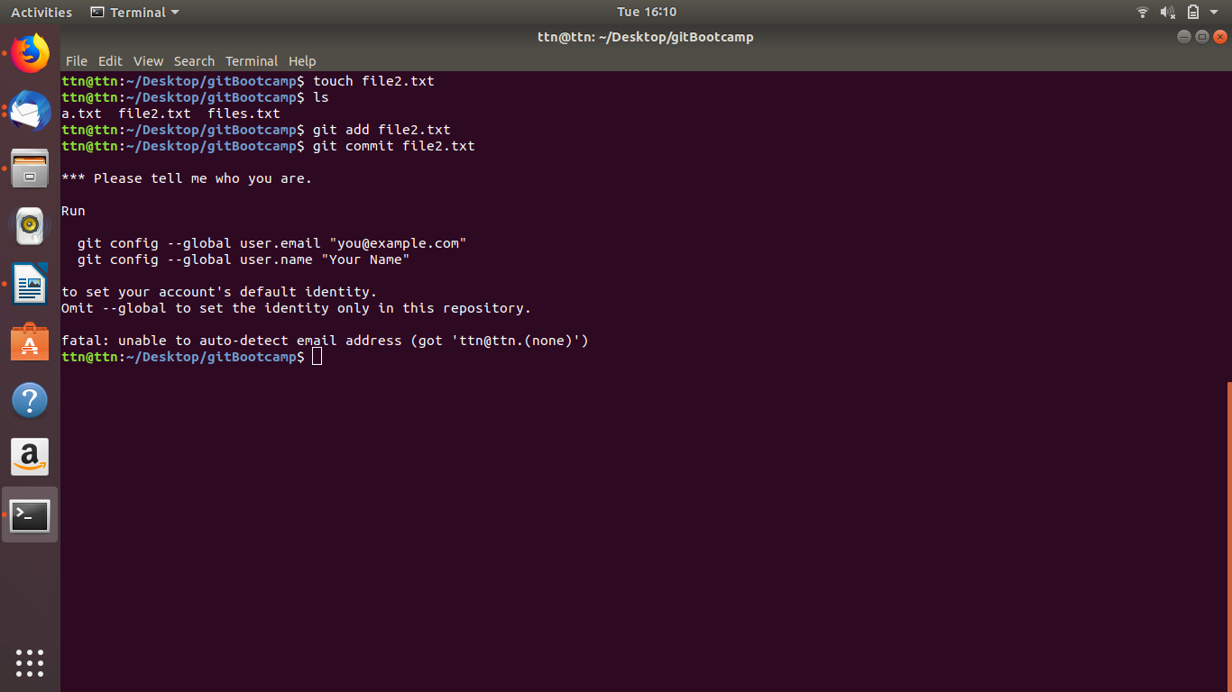

Q.6. Add a remote.
Ans:
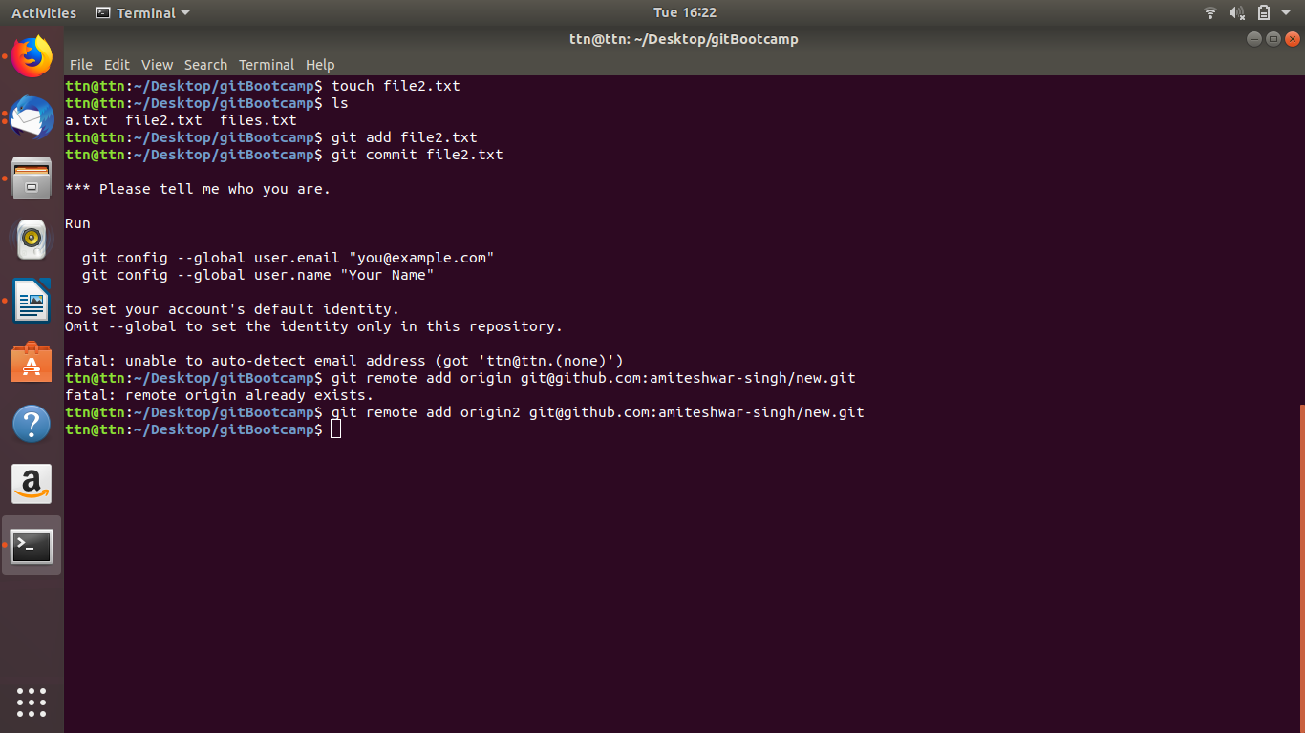
git remote add origin URL
URL: git@github.com:amiteshwar-singh/new.git

Q.7. Undo changes to a particular file
Ans: get checkout filename
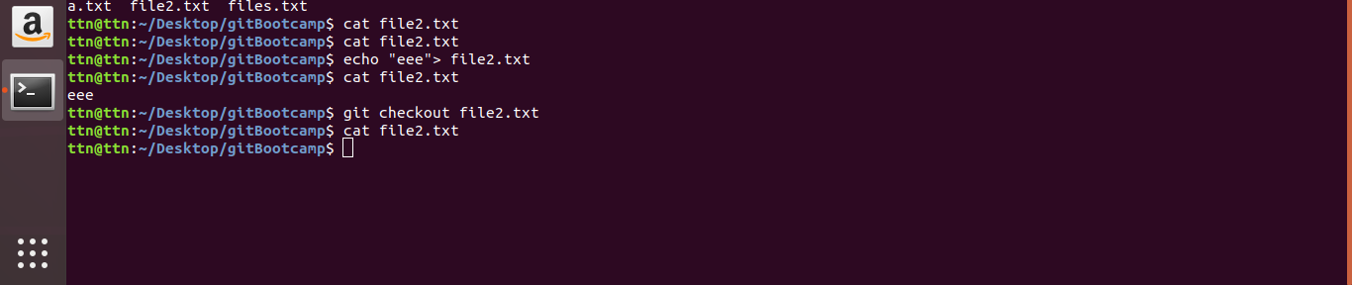

Q.8. Push changes to Github
Ans:
git push origin2 master
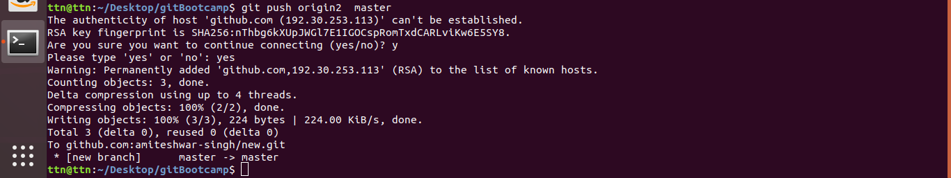
Q.9.
Ans: git clone <url>

git clone

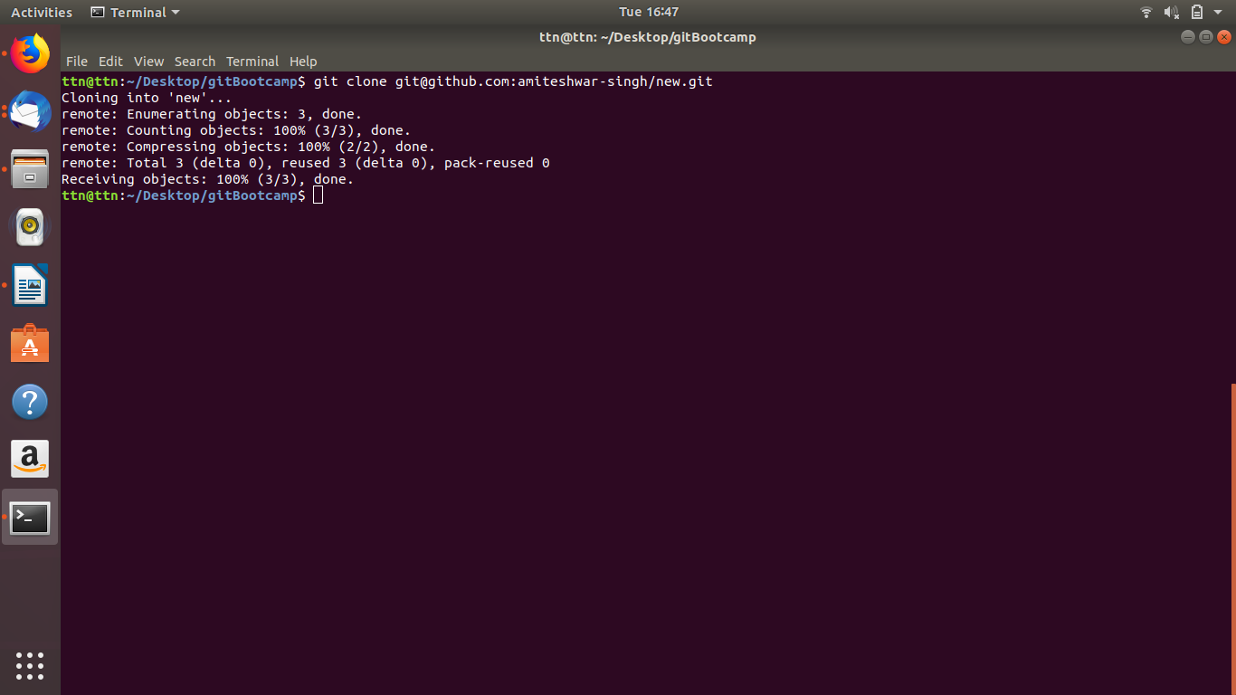

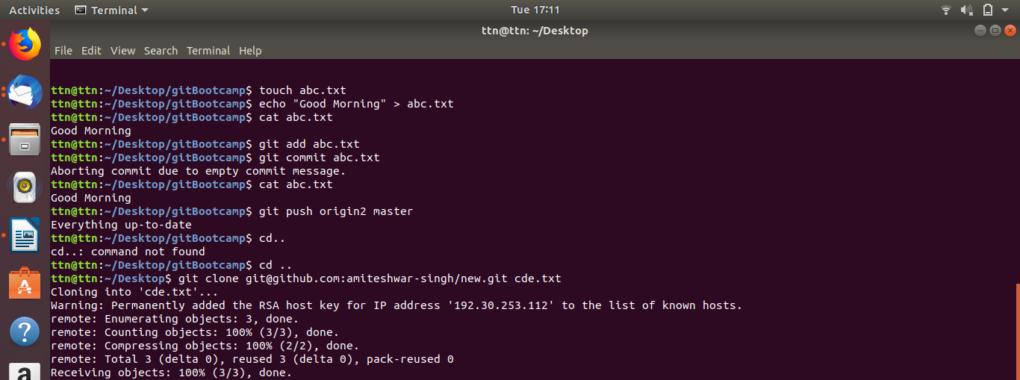
Q.10.

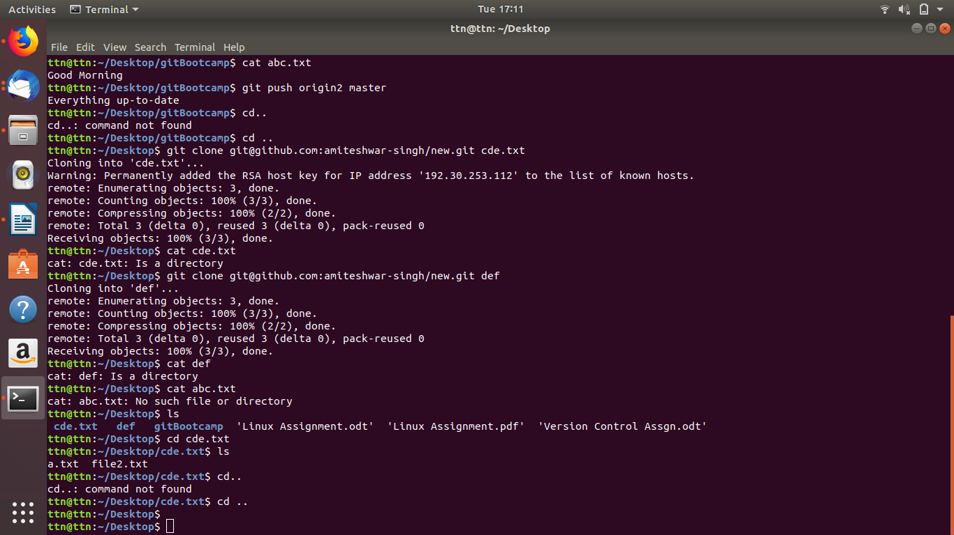

Q.11.
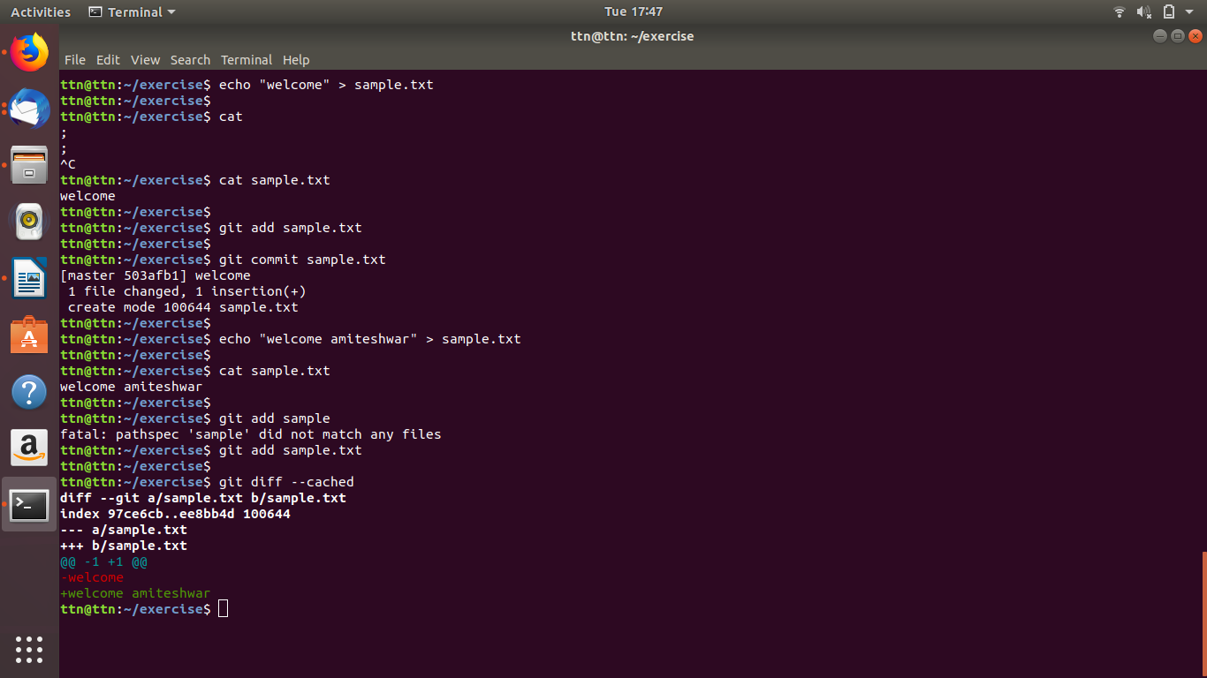
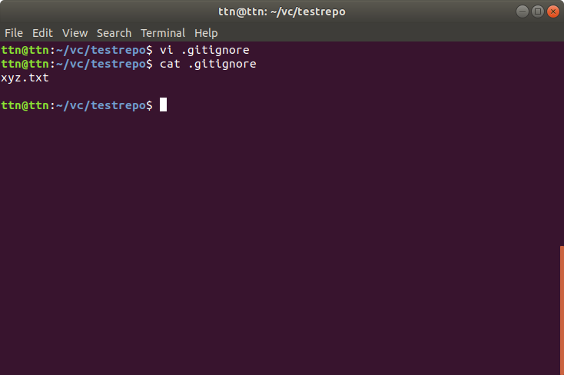

Q.12 Ignore a few files to be checked in

Q.13 Create a new branch.
Ans:
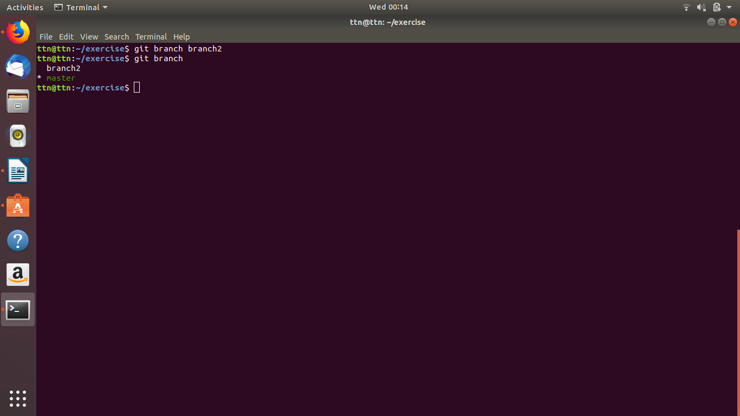

Q.14 Diverge them with commits
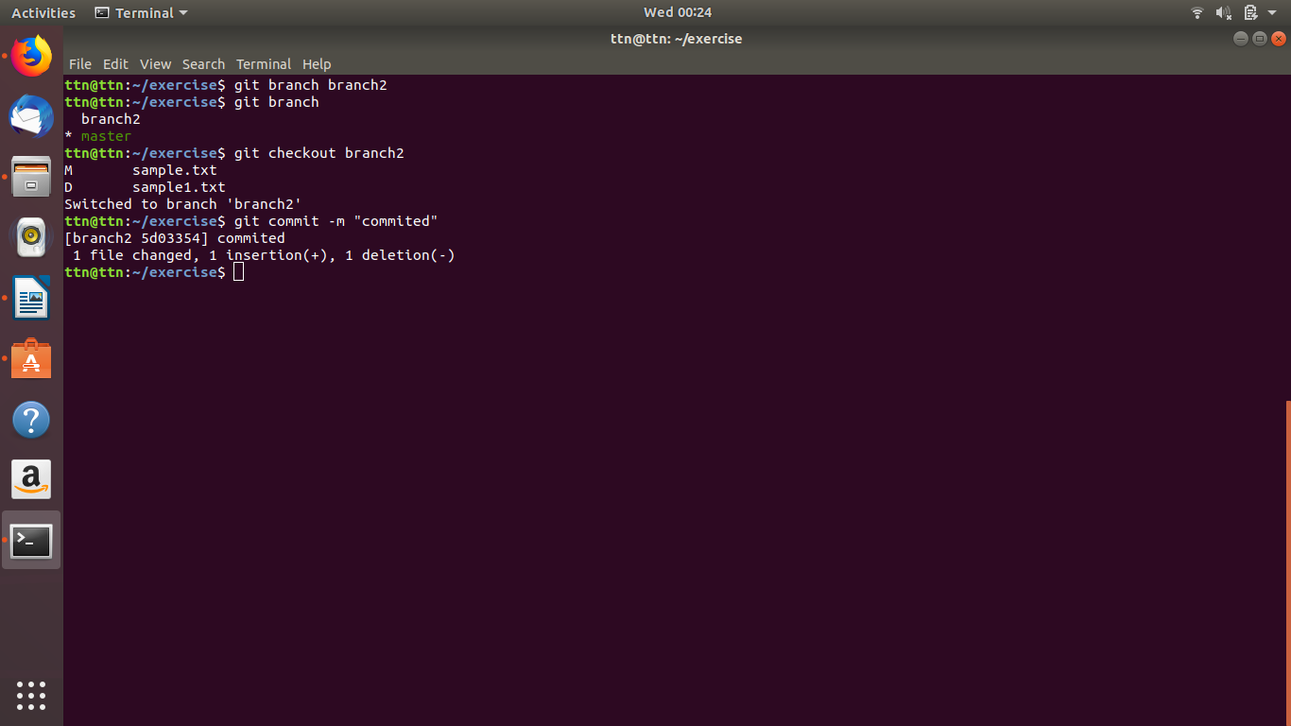

Q.15.Edit the same file at the same line on both branches and commit
Ans:

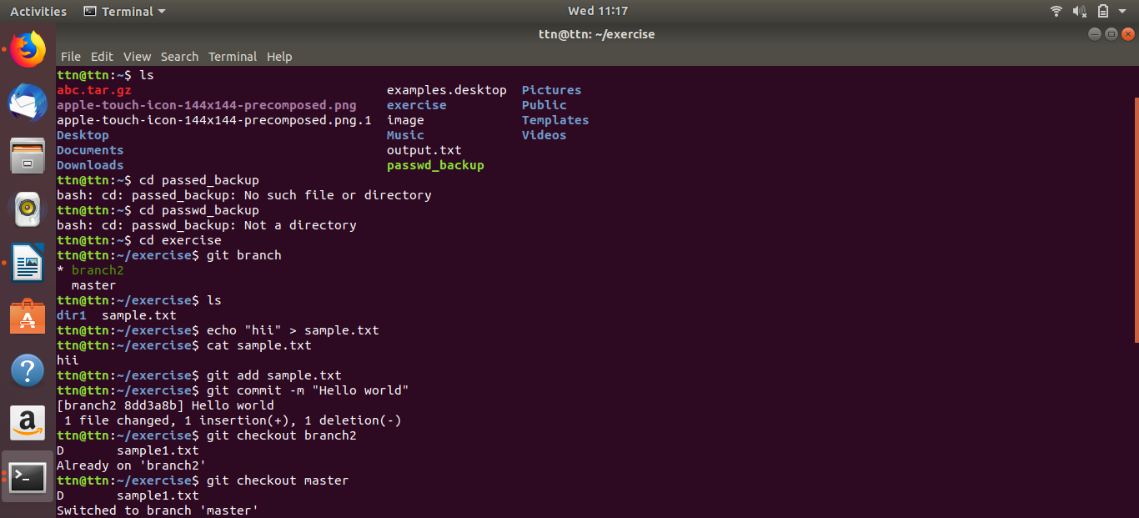

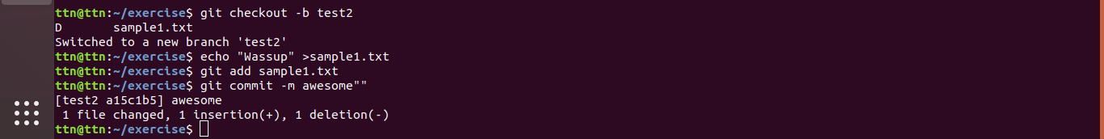

Q.16.
Ans:
1) Open Terminal.
2)Navigate into the local Git repository that has the merge conflict.
3)Generate a list of the files affected by the merge conflict. In this example, the file README.md has a merge conflict.
4)Open a text editor, such as Atom, and navigate to the file that has merge conflicts.
5) Decide if you want keep the removed file. You may want to view the latest changes made to the removed file in your text editor.
To add the removed file back to your repository:
git add README.md

To remove this file from your repository:
git rm README.md

6) Commit your changes with a comment.
git commit -m "Resolved merge conflict by keeping README.md file."

7) Merge the branches on the command line or push the change on the remote repository on GitHub and merge the changes in a pull request.

Q.17.
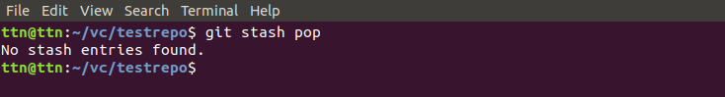

Q.18
